Assignment 5.

Introduction to JavaScript

**Members:** Asanali, Askhat, Asylkhan

Group: SE-2416

**Task 1.Form Validation**

We have writed JavaScript code to validate form data.

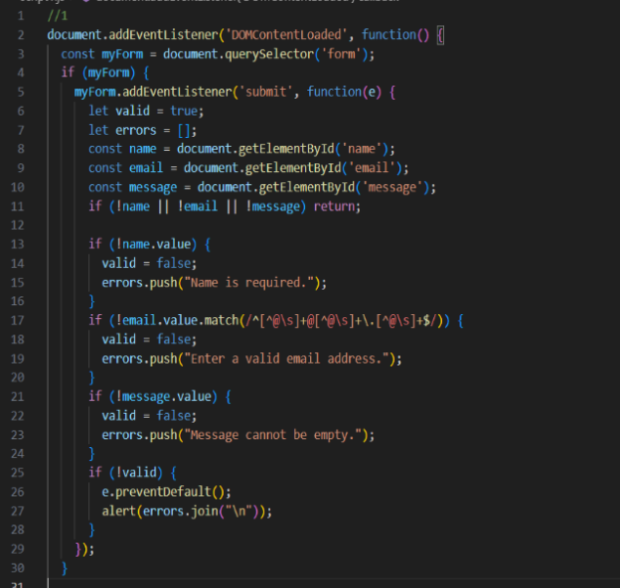

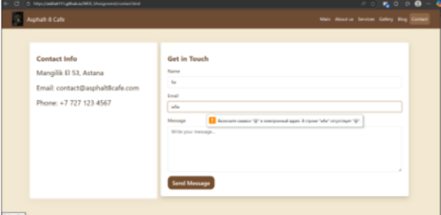

**Task 2.Accordion for FAQs or Content Sections**

We have builded a webpage where clicking on a question reveals or hides the content below it.

We have created a list of frequently asked questions (Q&A).Each question is clickable, and the content is hidden.

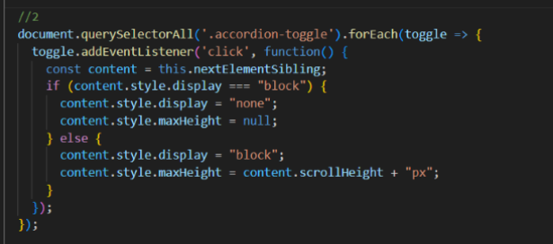

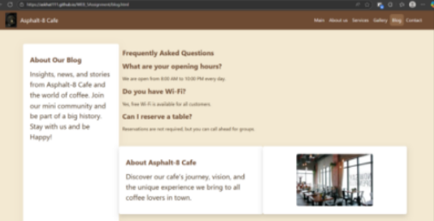

**Task 3.Popup Subscription or Contact Form**

We have Created a pop-up form that appears when a button is clicked.

When the user clicks a button "Subscribe" the form in a pop-up window appears. The user can close the form by clicking a close button or

outside the pop-up area.

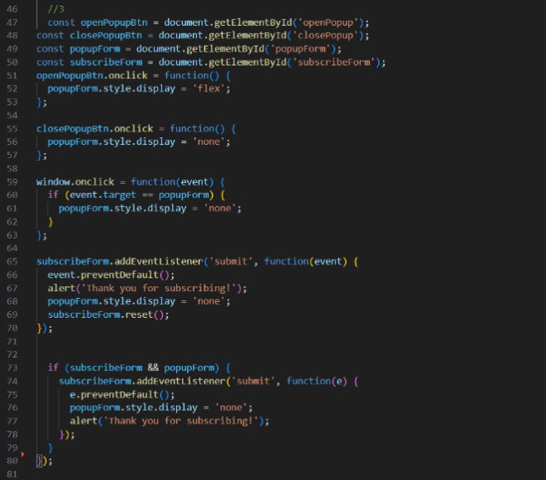

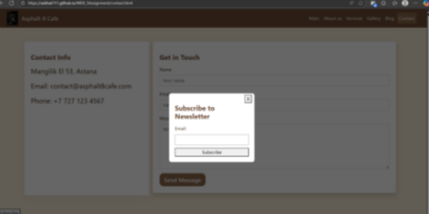

**Task 4. Change Background Color with JavaScript**

Explanation:

In this task, you need to change the background color of the page by clicking a button using JavaScript. To solve the problem, I created a button using the <button> tag, and then using JavaScript added an event handler for clicking it. When the button is clicked, a function is called that changes the background color of the <body> using the style property.background.

Example:

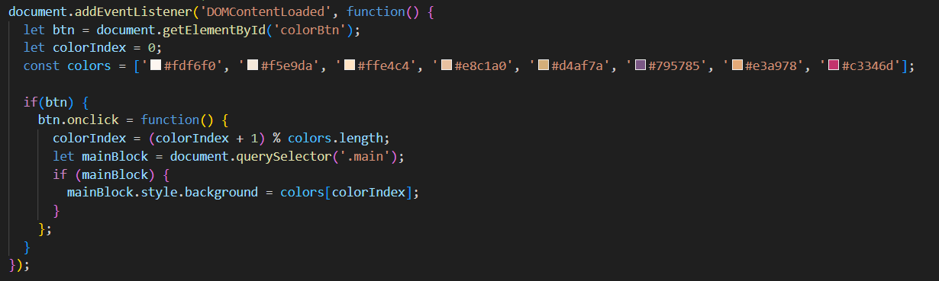

**Task 5. Display Current Date and Time**

Explanation:

The built-in JavaScript Date object was used to display the current date and time. An instance was created in the script:

const now = new Date();

Using the methods (getFullYear(), getMonth(), getDate(), getHours(), getMinutes()), the necessary date and time components were obtained, which were then formatted into a convenient string. This line is dynamically displayed in the right place on the page and can be updated automatically. This approach allows the user to see the current date and time every time they visit the page.

Example:

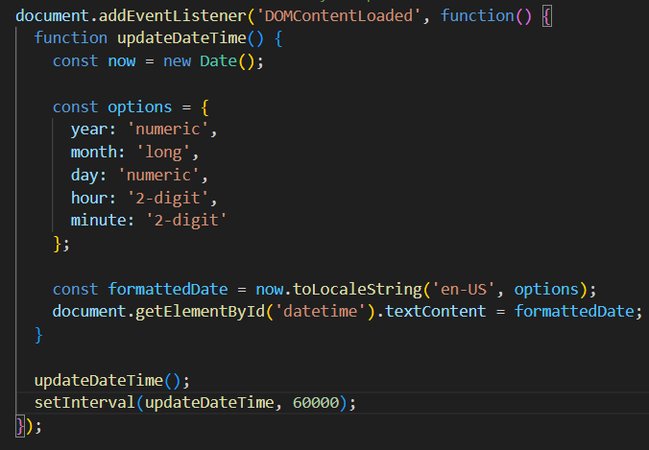<https://github.com/Askhat111/WEB_5Assignment>